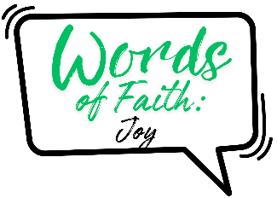
Words of Faith: Joy
Peace Lutheran Church
June 28, 2026

Welcome to Peace!
We are so glad you are here! Everything needed for worship will be projected on the screen. Below you will find a few notes about worship as well as announcements for upcoming events.

Reading – Psalm 126

Gospel – Luke 2:8-14

Hymns
Gathering Hymn – ELW #836 “Joyful, Joyful We Adore Thee”

Hymn of the Day – ACS #1097 “Ten Thousand Reasons”

Blessing – ACS #984 “May the God of Hope Go With Us”

Sending Hymn – ELW #866 “We Are Marching in the Light”

Offering
Members are encouraged to help support the mission and ministry of Peace. If you are visiting Peace, please be our guests. Your presence is a gift to our community.

Distribution of Holy Communion
All who believe in the real presence of Christ are welcome to receive the gift of this meal. You are welcome no matter who you are, where you’ve been or what you’ve done. This is God’s gift of grace for you. Gluten-free bread and wine is served, with grape juice available for those who prefer. Those who do not commune are welcome to come forward for a blessing.

Announcements
Please sign our red pew pad to let us know you worshipped with us today.

Sundays and Seasons v.20251125.1626 © 2026 Augsburg Fortress. All rights reserved. Scripture quotations are from New Revised Standard Version Bible, Updated Edition, © 2021, Division of Christian Education of the National Council of the Churches of Christ in the United States of America. Used by permission. All rights reserved. Other liturgies from Evangelical Lutheran Worship © 2006 Augsburg Fortress. License SAS027014. Used with permission. “Love Has Brought Us Here Together” Text: ©2010 GIA Publications, Inc. “Ten Thousand Reasons” Text & Tune: © 2011 admin Capitol CMG Publishing. “We Are Marching in the Light” Text & Tune: ©1984 Walton Music. All rights reserved. ONE LICENSE, License #734442. All other hymns are public domain. All rights reserved.
This Week at Peace: June 28 – July 5

Monday: Women’s Bible Study – 1:00 PM
Tomah Community Table Meal – 4:30 PM

Tuesday: Mission Quilting – 9:30 AM

Wednesday: Unwind Wednesday – 6:30 PM

Thursday: Cuppa Joe & Jesus – 8:30 AM
T & T Quilting – 9:30 AM

Sunday: Worship – 9:30 AM

Looking Ahead

July 6-12: Pastor Dawn on Vacation

August 14-15: Feed My Starving Children

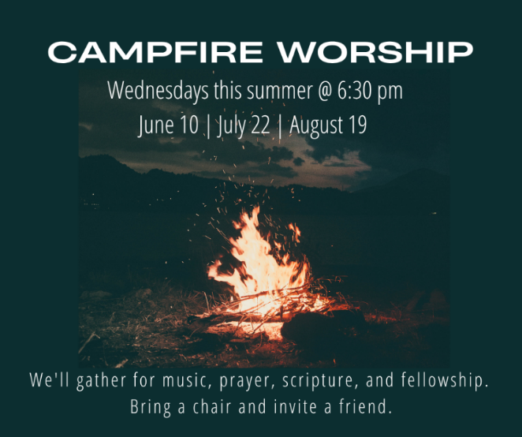

August 30: Ecumenical Worship in the Park

