
Pentecost
Peace Lutheran Church
May 24, 2026

Welcome to Peace!
We are so glad you are here! Everything needed for worship will be projected on the screen. Below you will find a few notes about worship as well as announcements for upcoming events.

Reading – Philippians 4:4-7

Reading 1 – Acts 2:1-21

Hymns
Gathering Hymn – ELW #396 “Spirit of Gentleness”

Hymn of the Day – ACS #944 “O Spirit All-Embracing”

Sending Hymn – ELW #400 “God of Tempest, God of Whirlwind”

Offering
Members are encouraged to help support the mission and ministry of Peace. If you are visiting Peace, please be our guests. Your presence is a gift to our community.

Distribution of Holy Communion
All who believe in the real presence of Christ are welcome to receive the gift of this meal. You are welcome no matter who you are, where you’ve been or what you’ve done. This is God’s gift of grace for you. Gluten-free bread and wine is served, with grape juice available for those who prefer. Those who do not commune are welcome to come forward for a blessing.

Announcements
Please sign our red pew pad to let us know you worshipped with us today.

Call to Worship Copyright © 2012 Reformed Church Press. https://www.rca.org/. From sundaysandseasons.com. Sundays and Seasons v.20251125.1626 © 2026 Augsburg Fortress. All rights reserved. Scripture quotations are from New Revised Standard Version Bible, Updated Edition, © 2021, Division of Christian Education of the National Council of the Churches of Christ in the United States of America. Used by permission. All rights reserved. Other liturgies from Evangelical Lutheran Worship © 2006 Augsburg Fortress. License SAS027014. Used with permission. “Spirit of Gentleness” Text: & Tune: © 1978, J. Manley Publishing. “O Spirit All-Embracing” Text: © 2003, GIA Publications, Inc. “God of Tempest, God of Whirlwind” Text: © 2000, GIA Publications, Inc. All rights reserved. ONE LICENSE, License #734442. All other hymns are public domain. All rights reserved.
This Week at Peace: May 24 – 31

Monday: Memorial Day **Office Closed**

Tuesday: Mission Quilting – 9:30 AM

Thursday: Cuppa Joe & Jesus – 8:30 AM
T & T Quilting – 9:30 AM

Sunday: Pride Sunday Worship – 9:30 AM
-Noisy Offering for Feed My Starving Children

Looking Ahead

June 2: Men’s Faith Roundtable

June 6: Synod Assembly

June 7: Synod Worship Service @ Riverside Park, La Crosse – 10:00 AM

June 10: Campfire Worship – 6:30 PM

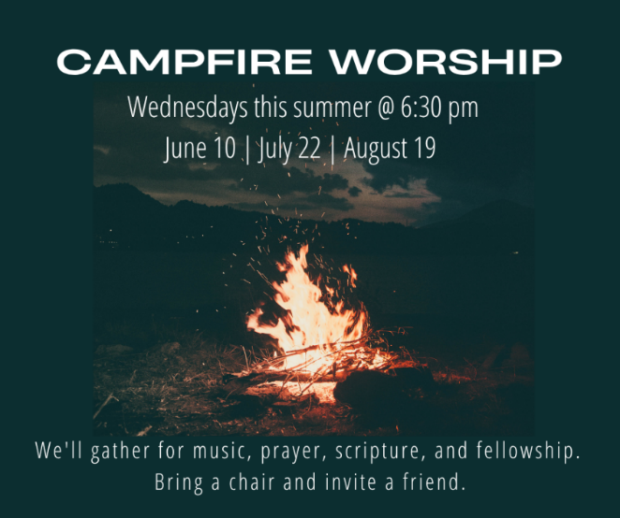

June 16: Women, Wine, & the Word – 6:30 PM

