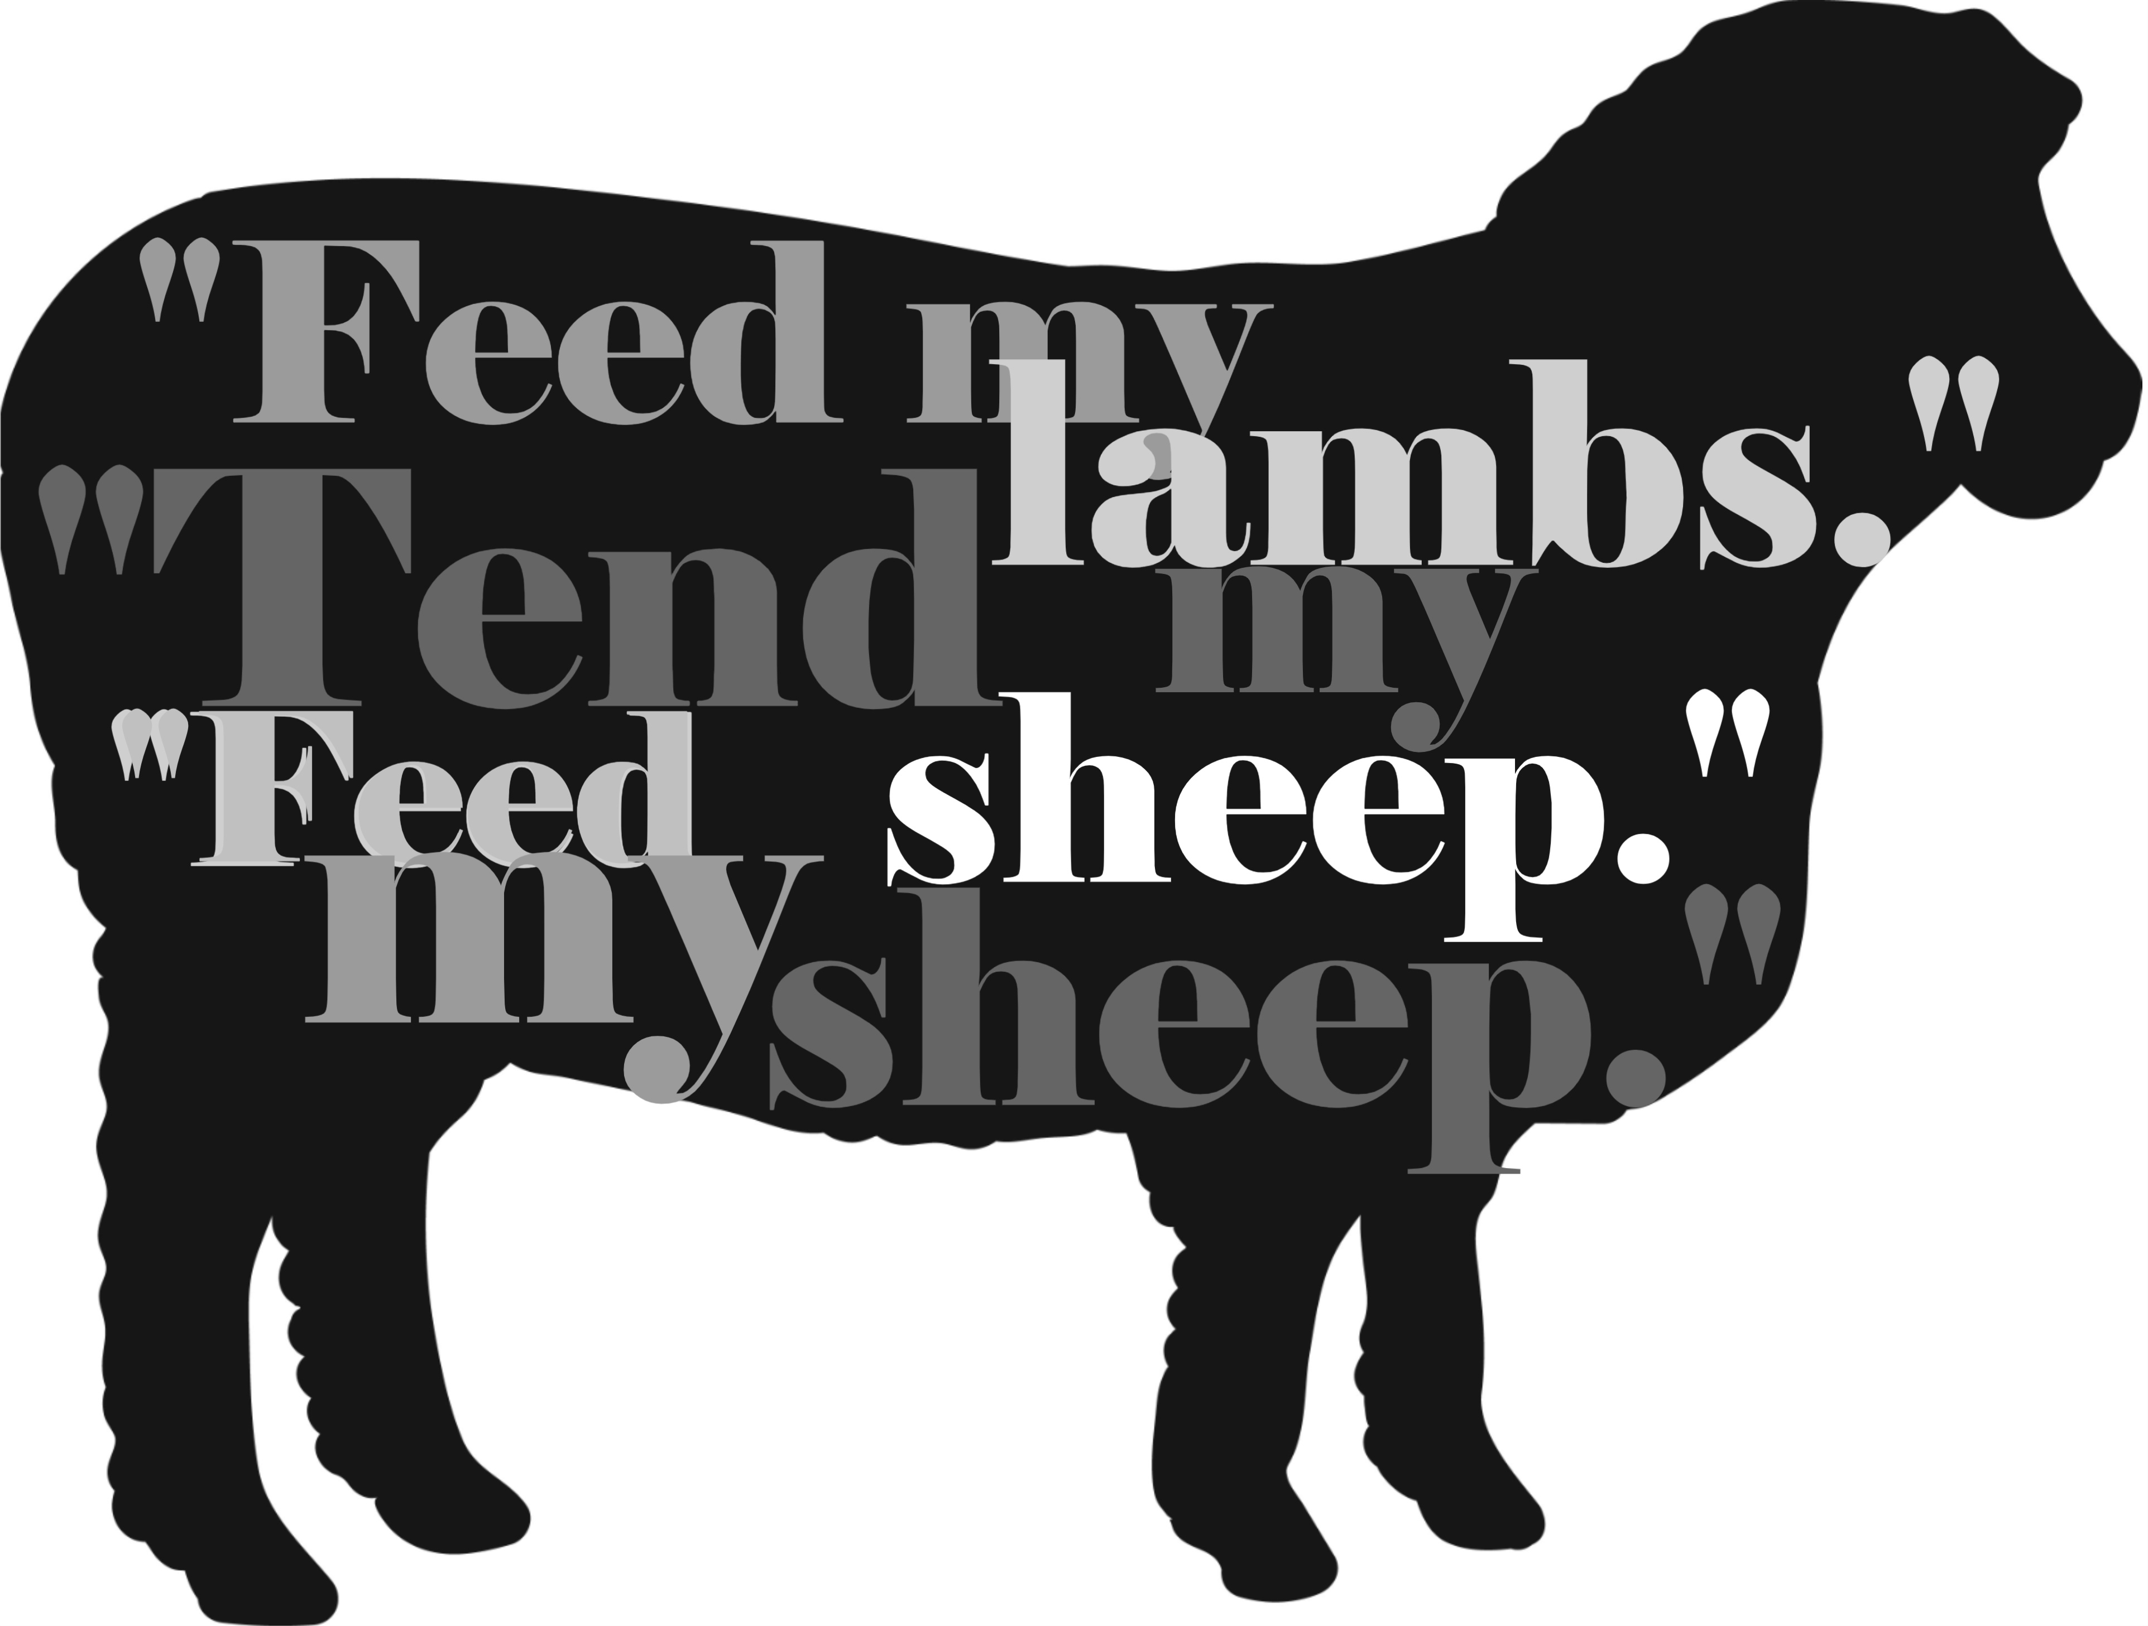
Jesus and Simon Peter
Peace Lutheran Church
April 26, 2026

Welcome to Peace!
We are so glad you are here! Everything needed for worship will be projected on the screen. Below you will find a few notes about worship as well as announcements for upcoming events.

Psalm 23

Gospel Reading – John 21:15-19

Hymns
Gathering Hymn – ELW #666 “What Wondrous Love is This”

Hymn of the Day – ELW #780 “Shepherd Me, O God”

Sending Hymn – ELW #385 “Good Christian Friends, Rejoice and Sing”

Offering
Members are encouraged to help support the mission and ministry of Peace. If you are visiting Peace, please be our guests. Your presence is a gift to our community.

Distribution of Holy Communion
All who believe in the real presence of Christ are welcome to receive the gift of this meal. You are welcome no matter who you are, where you’ve been or what you’ve done. This is God’s gift of grace for you. Gluten-free bread and wine is served, with grape juice available for those who prefer. Those who do not commune are welcome to come forward for a blessing.

Announcements
Please sign our red pew pad to let us know you worshipped with us today.

From sundaysandseasons.com. Sundays and Seasons v.20251125.1626 © 2026 Augsburg Fortress. All rights reserved. Scripture quotations are from New Revised Standard Version Bible, Updated Edition, © 2021, Division of Christian Education of the National Council of the Churches of Christ in the United States of America. Used by permission. All rights reserved. Other liturgies from Evangelical Lutheran Worship © 2006 Augsburg Fortress. License SAS027014. Used with permission. “What Wondrous Love is This” Tune: © 1955 Augsburg Fortress. “Beloved, God’s Chosen” Text & Tune: © 1994, Augsburg Fortress. “Good Christian Friends, Rejoice and Sing” Text: © 1952, 1986 Hymns Ancient & Modern (admin. Hope Publishing Company). All rights reserved. ONE LICENSE, License #734442. All other hymns are public domain. All rights reserved.
This Week at Peace: April 26 – May 3
Today: Worship – 9:30 AM

Monday: Women’s Bible Group – 1:00 PM
Community Table Meal – 4:30 PM
Bells Practice – 6:00 PM

Tuesday: Mission Quilting – 9:30 AM

Wednesday: Confirmation – 6:30 PM

Thursday: Cuppa Joe & Jesus – 8:30 AM
T & T Quilting – 9:30 AM

Sunday: God’s Work. Our Hands. Sunday
Worship – 9:30 AM
Service Projects – 10:00 PM
Potluck Lunch – 12:00 PM

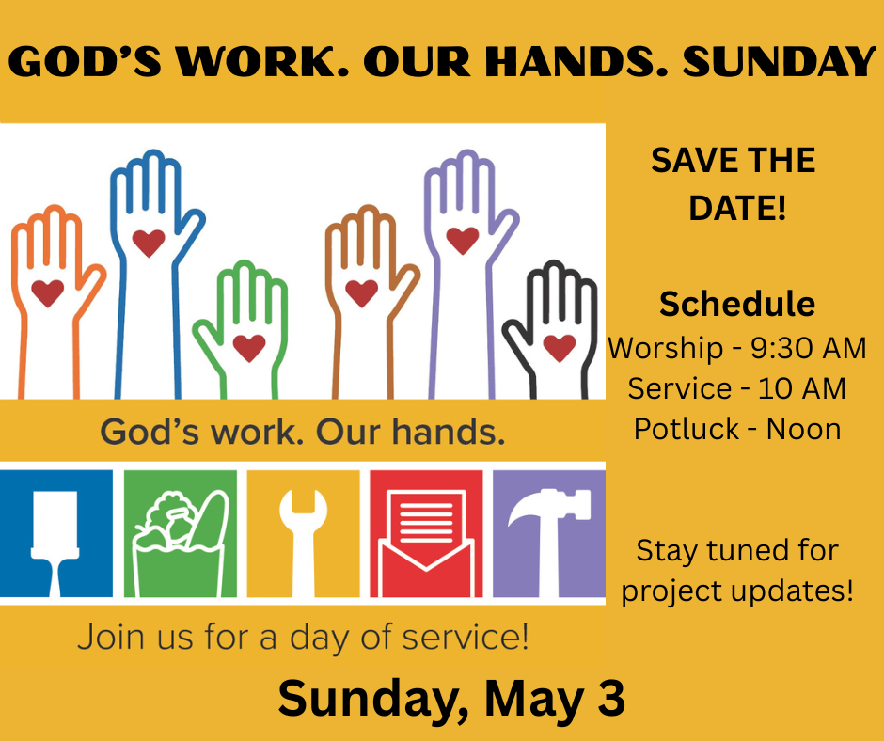
Jesus and Simon Peter
Peace Lutheran Church
April 26, 2026

Welcome to Peace!
We are so glad you are here! Everything needed for worship will be projected on the screen. Below you will find a few notes about worship as well as announcements for upcoming events.

Psalm 23

Gospel Reading – John 21:15-19

Hymns
Gathering Hymn – ELW #666 “What Wondrous Love is This”

Hymn of the Day – ELW #780 “Shepherd Me, O God”

Sending Hymn – ELW #385 “Good Christian Friends, Rejoice and Sing”

Offering
Members are encouraged to help support the mission and ministry of Peace. If you are visiting Peace, please be our guests. Your presence is a gift to our community.

Distribution of Holy Communion
All who believe in the real presence of Christ are welcome to receive the gift of this meal. You are welcome no matter who you are, where you’ve been or what you’ve done. This is God’s gift of grace for you. Gluten-free bread and wine is served, with grape juice available for those who prefer. Those who do not commune are welcome to come forward for a blessing.

Announcements
Please sign our red pew pad to let us know you worshipped with us today.

From sundaysandseasons.com. Sundays and Seasons v.20251125.1626 © 2026 Augsburg Fortress. All rights reserved. Scripture quotations are from New Revised Standard Version Bible, Updated Edition, © 2021, Division of Christian Education of the National Council of the Churches of Christ in the United States of America. Used by permission. All rights reserved. Other liturgies from Evangelical Lutheran Worship © 2006 Augsburg Fortress. License SAS027014. Used with permission. “What Wondrous Love is This” Tune: © 1955 Augsburg Fortress. “Beloved, God’s Chosen” Text & Tune: © 1994, Augsburg Fortress. “Good Christian Friends, Rejoice and Sing” Text: © 1952, 1986 Hymns Ancient & Modern (admin. Hope Publishing Company). All rights reserved. ONE LICENSE, License #734442. All other hymns are public domain. All rights reserved.
This Week at Peace: April 26 – May 3
Today: Worship – 9:30 AM

Monday: Women’s Bible Group – 1:00 PM
Community Table Meal – 4:30 PM
Bells Practice – 6:00 PM

Tuesday: Mission Quilting – 9:30 AM

Wednesday: Confirmation – 6:30 PM

Thursday: Cuppa Joe & Jesus – 8:30 AM
T & T Quilting – 9:30 AM

Sunday: God’s Work. Our Hands. Sunday
Worship – 9:30 AM
Service Projects – 10:00 PM
Potluck Lunch – 12:00 PM

