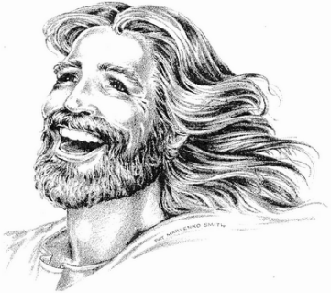
Holy Humor Sunday
Peace Lutheran Church
April 12, 2026

Welcome to Peace!
We are so glad you are here! Everything needed for worship will be projected on the screen. Below you will find a few notes about worship as well as announcements for upcoming events.

Gospel Reading – John 20:19-31

Hymns
Song of Joy – “Shake Another Hand”

Hymn of Joy – “Joy to the World”

Gospel Acclamation – ELW #836 “Joyful, Joyful We Adore Thee” (Verse 1)

Sermon Song – “Alleluia, Praise Ye the Lord”

Sending Song – “If You’re Happy and You Know It”

Offering
Members are encouraged to help support the mission and ministry of Peace. If you are visiting Peace, please be our guests. Your presence is a gift to our community.

Distribution of Holy Communion
All who believe in the real presence of Christ are welcome to receive the gift of this meal. You are welcome no matter who you are, where you’ve been or what you’ve done. This is God’s gift of grace for you. Gluten-free bread and wine is served, with grape juice available for those who prefer. Those who do not commune are welcome to come forward for a blessing.

Announcements
Please sign our red pew pad to let us know you worshipped with us today.

Affirmation of Humor compiled by Chris Anderson with help from the Joyful Noiseletter. Blessing adapted from © 2002 Nathan Nettleton, on his site Laughing Bird Liturgical Resource. All rights reserved. Scripture quotations are from New Revised Standard Version Bible, Updated Edition, © 2021, Division of Christian Education of the National Council of the Churches of Christ in the United States of America. Used by permission. All rights reserved. Other liturgies from Evangelical Lutheran Worship © 2006 Augsburg Fortress. License SAS027014. Used with permission. ONE LICENSE, License #734442. All other hymns are public domain. All rights reserved.
This Week at Peace: April 12 - 19
Monday: Women’s Bible Study – 1:00 PM

Tuesday: Mission Quilting – 9:30 AM

Wednesday: Wired Wednesday @ Starbucks – 6:45 AM
Confirmation – 6:30 PM

Thursday: Cuppa Joe & Jesus – 8:30 AM
T & T Quilting – 9:30 AM

Friday: Friday Fish Fellowship @ 400 Club, Millston – 5:30 PM

Sunday: Worship – 9:30 AM
Mission Trip Raffle Drawing – 10:30 AM
All Ministry Meeting – 11:00 AM

