
Jesus Condemned
Peace Lutheran Church
March 22, 2026

Welcome to Peace!
We are so glad you are here! Everything needed for worship will be projected on the screen. Below you will find a few notes about worship as well as announcements for upcoming events.

Scripture Reading – John 19:1-16a

Hymns
Gathering Hymn – ELW #843 “Praise the One who Breaks the Darkness”

Hymn of the Day – ELW #325 “I Want Jesus to Walk with Me”

Sending Hymn – ELW #660 “Lift High the Cross”

Offering
Members are encouraged to help support the mission and ministry of Peace. If you are visiting Peace, please be our guests. Your presence is a gift to our community.

Distribution of Holy Communion
All who believe in the real presence of Christ are welcome to receive the gift of this meal. You are welcome no matter who you are, where you’ve been or what you’ve done. This is God’s gift of grace for you. Gluten-free bread and wine is served, with grape juice available for those who prefer. Those who do not commune are welcome to come forward for a blessing.

Announcements
Please sign our red pew pad to let us know you worshipped with us today.



This Week at Peace: March 22 – 29
Monday: Women’s Bible Study – 1:00 PM
Bells Practice – 6:00 PM

Tuesday: Mission Quilting – 9:30 AM

Wednesday: Soup Supper – 5:30 PM
Lent Worship – 6:30 PM

Thursday: Cuppa Joe & Jesus – 8:30 AM
T & T Quilting – 9:30 AM

Sunday: Bells Practice – 8:30 AM
Choir Practice – 8:45 AM
Palm Sunday Worship – 9:30 AM
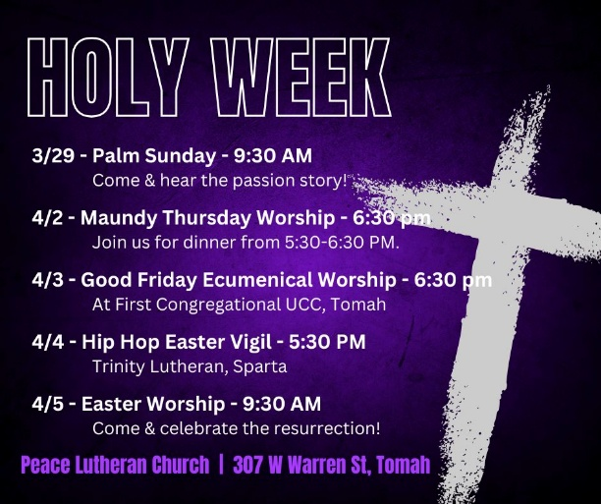

From sundaysandseasons.com. Sundays and Seasons v.20251125.1626 © 2026 Augsburg Fortress. All rights reserved. Scripture quotations are from New Revised Standard Version Bible, Updated Edition, © 2021, Division of Christian Education of the National Council of the Churches of Christ in the United States of America. Used by permission. All rights reserved. Other liturgies from Evangelical Lutheran Worship © 2006 Augsburg Fortress. License SAS027014. Used with permission. “Praise the One who Breaks the Darkness” Text: © 1987 Hope Publishing Company “I Want Jesus to Walk with Me” Tune: arr. © 2006, Augsburg Fortress. “Lift High the Cross” Text & Tune: © 1974 Hope Publishing Company. All rights reserved. ONE LICENSE, License #734442. All other hymns are public domain. All rights reserved.

