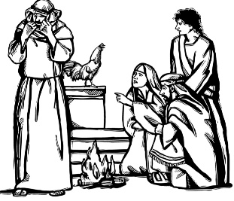
Peter’s Denial
Peace Lutheran Church
March 8, 2026

Welcome to Peace!
We are so glad you are here! We have moved away from bulletins for the time being and will have everything needed for worship projected on the screen. Below you will find a few notes about worship as well as announcements for upcoming events.

Scripture Reading – John 18:12-27

Hymns
Gathering Hymn – ELW #666 “What Wonderous Love is This”

Hymn of the Day – ELW #609 “Chief of Sinners Though I Be”
(Verses 1, 2, 4, & 5)

Sending Hymn – ELW #618 “Guide Me Ever, Great Redeemer”

Offering
Members are encouraged to help support the mission and ministry of Peace. If you are visiting Peace, please be our guests. Your presence is a gift to our community.

Distribution of Holy Communion
All who believe in the real presence of Christ are welcome to receive the gift of this meal. You are welcome no matter who you are, where you’ve been or what you’ve done. This is God’s gift of grace for you. Gluten-free bread and wine is served, with grape juice available for those who prefer. Those who do not commune are welcome to come forward for a blessing.

Announcements
Please sign our red pew pad to let us know you worshipped with us today.


This Week at Peace: March 8 - 15
Today: Worship – 9:30 AM
Hope & Healing Service, Tomah UMC – 6:30 PM

Monday: Women’s Bible Study – 1:00 PM
Bells Practice – 6:00 PM

Tuesday: Mission Quilting – 9:30 AM
Culver’s Tip Night for Youth Mission Trip – 4:00-7:00 PM

Wednesday: Soup Supper – 5:30 PM
Lent Worship – 6:30 PM

Thursday: Cuppa Joe & Jesus – 8:30 AM
T & T Quilting – 9:30 AM
Council Meeting – 6:30 PM

Friday: Friday Fish Fellowship @ Schmitty’s, Valley Junction – 5:30 PM

Saturday: Women’s Retreat – 9:00 AM-4:00 PM

Sunday: Worship – 9:30 AM

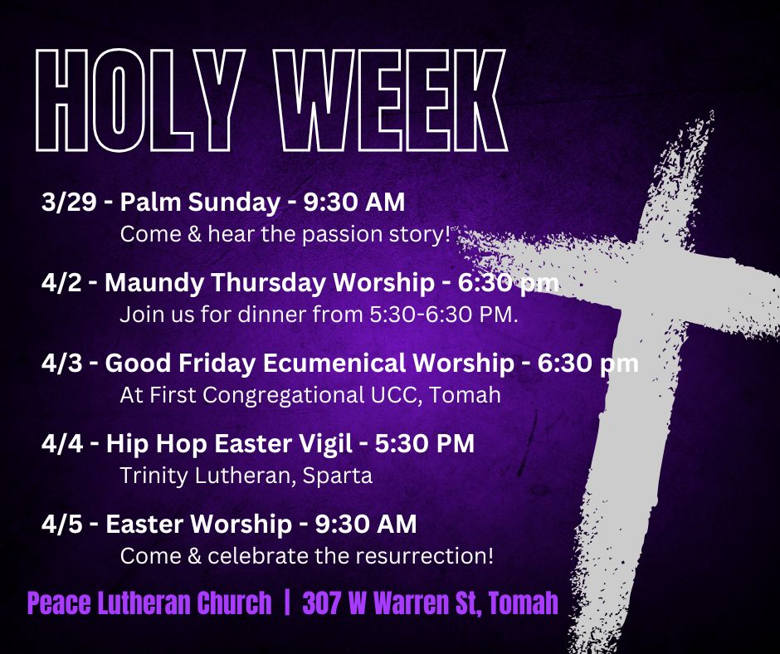
Looking Ahead
April 2 – Maundy Thursday

April 3 – Good Friday

April 4 – Hip Hop Easter Vigil

April 5 – Easter Sunday

From sundaysandseasons.com. Sundays and Seasons v.20251125.1626 © 2026 Augsburg Fortress. All rights reserved. Scripture quotations are from New Revised Standard Version Bible, Updated Edition, © 2021, Division of Christian Education of the National Council of the Churches of Christ in the United States of America. Used by permission. All rights reserved. Other liturgies from Evangelical Lutheran Worship © 2006 Augsburg Fortress. License SAS027014. Used with permission. “What Wonderous Love is This” Tune: © 1955 Augsburg Fortress. “Chief of Sinners Though I Be” Tune: Setting © 2003 Augsburg Fortress. All rights reserved. ONE LICENSE, License #734442. All other hymns are public domain. All rights reserved.

