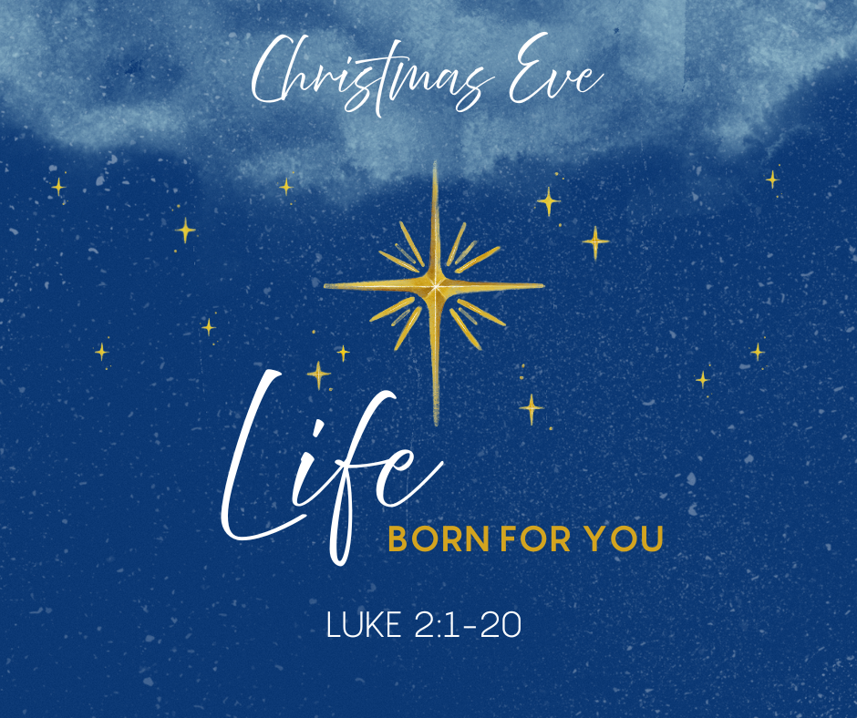
Christmas Eve Worship – 6:30 PM

Peace Lutheran Church
Welcome to Peace!

Merry Christmas! We are so glad you are worshipping with us this night as we gather to hear the story of our Lord and Savior, Jesus Christ. There can be plenty of darkness in the world around us, but we pray you might find hope and peace in the coming of the Christ child, the light of the world. May the love of God surround you this night.

We, at Peace Lutheran, hope that you feel welcome here. If you’re new to Peace, here are a few things you might want to know about worship.

• Tonight, we will share in Holy Communion. All who believe in Jesus Christ are welcome to participate. You will be ushered forward from the back of the sanctuary to receive the body and blood of Jesus Christ through the bread and wine/juice. The juice will be light colored and at the center of the communion tray. The bread is gluten free.

• Children are an important part of our worshipping community, so we welcome children to participate throughout the service. There are activity bags near the entrance that children are welcome to explore during worship.

• Bathrooms are available in the fellowship area down the short hallway near the kitchen. There is also a gender-neutral bathroom through the door at the back of the sanctuary.

• If you have any questions or need help, please see one of our ushers near the entrance.

We thank you for worshipping with us. If you are looking for a place of worship, please consider joining us again any Sunday morning at 9:30 am.

May your Christmas be joyous!

Pastor Dawn


Christmas Eve
December 24, 2025 – 6:30 PM
Leader/All
GATHERING

Bell Choir – “Stille, Stille, Stille”

Call to Worship
The night is quiet; the world is waiting.
Christ is born for us.

Light breaks in, gentle and fierce.
Jesus comes, bringing life that no darkness can overcome.

Love takes on flesh and dwells among us.
Christ is born for us—bringing life to all the world.

Come, let us worship the Holy Child.
O Come, let us adore him.

Carol – ELW #283 “Oh Come, All Ye Faithful”

Lighting the Advent Wreath

Advent Song – “Now It’s Time to Light the Candle” (Verse 4)

Confession and Forgiveness
Blessed be the holy Trinity, + one God, who sends the Word made flesh to dwell among us, who brings light into our darkness, who gathers us into grace and peace. Amen.

Let us confess our sin in the presence of God and of one another.
Silence for reflection.

Merciful God, we confess that we are broken by sin and weighed down by all that separates us from you. On this holy night, when you come among us as the true Light, we confess the shadows we choose instead: our lack of compassion, our hurried hearts, our failure to welcome others as freely as you have welcomed us. Forgive us. Shine your mercy into our lives. Make us whole, that we may walk in your ways and bear your love in the world. Amen.

Hear the good news of great joy for all people:
In Christ’s birth, God has come near—a Savior who frees us from sin, fills us with peace, and renews the whole creation. In the name of Jesus Christ, your sins are forgiven. The light of Christ has come into the world.
Walk now in God’s peace. Amen.

Sharing the Peace
The peace of Christ be with you always.
And also with you.

Carol of Praise – ELW #267 “Joy to the World”

Prayer of the Day
Holy God, we celebrate with you the birth of your son, and together we sing, “Glory to God in the highest heaven, and on earth peace, goodwill among people!” May your peace dwell with us this night and always. Amen.

WORD

Scripture Reading – Isaiah 9:2-7
²The people who walked in darkness have seen a great light; those who lived in a land of deep darkness— on them light has shined. ³You have multiplied the nation, you have increased its joy; they rejoice before you as with joy at the harvest, as people exult when dividing plunder. ⁴For the yoke of their burden, and the bar across their shoulders, the rod of their oppressor, you have broken as on the day of Midian. ⁵For all the boots of the tramping warriors and all the garments rolled in blood shall be burned as fuel for the fire. ⁶For a child has been born for us, a son given to us; authority rests upon his shoulders; and he is named Wonderful Counselor, Mighty God, Everlasting Father, Prince of Peace. ⁷His authority shall grow continually, and there shall be endless peace for the throne of David and his kingdom. He will establish and uphold it with justice and with righteousness from this time onward and forevermore. The zeal of the Lord of hosts will do this.

Gospel Acclaimation – ELW #271 “I Am So Glad Each Christmas Eve”
(Verses 1 & 5)

The Christmas Story – Luke 2:1-20
¹In those days a decree went out from Emperor Augustus that all the world should be registered. ²This was the first registration and was taken while Quirinius was governor of Syria. ³All went to their own towns to be registered. ⁴Joseph also went from the town of Nazareth in Galilee to Judea, to the city of David called Bethlehem, because he was descended from the house and family of David. ⁵He went to be registered with Mary, to whom he was engaged and who was expecting a child. ⁶While they were there, the time came for her to deliver her child. ⁷And she gave birth to her firstborn son and wrapped him in bands of cloth, and laid him in a manger, because there was no place for them in the inn. To us is born a Savior. Jesus Christ our Lord.

⁸In that region there were shepherds living in the fields, keeping watch over their flock by night. ⁹Then an angel of the Lord stood before them, and the glory of the Lord shone around them, and they were terrified. ¹⁰But the angel said to them, “Do not be afraid; for see—I am bringing you good news of great joy for all the people: ¹¹to you is born this day in the city of David a Savior, who is the Messiah, the Lord. ¹²This will be a sign for you: you will find a child wrapped in bands of cloth and lying in a manger.” To us is born a Savior.
Jesus Christ our Lord.

¹³And suddenly there was with the angel a multitude of the heavenly host, praising God and saying, ¹⁴“Glory to God in the highest heaven, and on earth peace among those whom he favors!” ¹⁵When the angels had left them and gone into heaven, the shepherds said to one another, “Let us go now to Bethlehem and see this thing that has taken place, which the Lord has made known to us.” ¹⁶So they went with haste and found Mary and Joseph, and the child lying in the manger. To us is born a Savior. Jesus Christ our Lord.

¹⁷When they saw this, they made known what had been told them about this child; ¹⁸and all who heard it were amazed at what the shepherds told them. ¹⁹But Mary treasured all these words and pondered them in her heart. ²⁰The shepherds returned, glorifying and praising God for all they had heard and seen, as it had been told them. To us is born a Savior. Jesus Christ our Lord.

Sermon – Pastor Dawn Lindberg

Carol – ELW # 292 “Love Has Come”

Nicene Creed
We believe in one God,
the Father, the Almighty,
maker of heaven and earth,
of all that is, seen and unseen.

We believe in one Lord, Jesus Christ,
the only Son of God,
eternally begotten of the Father,
God from God, Light from Light,
true God from true God,
begotten, not made,
of one Being with the Father;
through him all things were made.
For us and for our salvation
he came down from heaven,
was incarnate of the Holy Spirit and the virgin Mary
and became truly human.
For our sake he was crucified under Pontius Pilate;
he suffered death and was buried.
On the third day he rose again
in accordance with the scriptures;
he ascended into heaven
and is seated at the right hand of the Father.
He will come again in glory to judge the living and the dead,
and his kingdom will have no end.

We believe in the Holy Spirit, the Lord, the giver of life,
who proceeds from the Father and the Son,
who with the Father and the Son is worshiped and glorified,
who has spoken through the prophets.
We believe in one holy catholic and apostolic church.
We acknowledge one baptism for the forgiveness of sins.
We look for the resurrection of the dead,
and the life of the world to come. Amen.

Prayers of the People
Empowered by the news of Christ’s birth, let us pray boldly for the church, creation, and all who are in need.

A brief silence.

Gathering God, you bring your people from every corner of the earth together before the manger that you have made a throne. Unite the church in love as we rejoice in the news of your coming. Hear us, O God. Your mercy is great.

Creating God, you brought forth the earth and all that is in it. Join our voices with the roaring seas, the exulting fields, and the trees of the forest singing for joy on this holy night. Hear us, O God. Your mercy is great.

Transforming God, the world trembles amid violence and war. Empower our hands, feet, and hearts with your Spirit to shatter the rod of the oppressor and turn swords into plowshares. Hear us, O God. Your mercy is great.

Shepherding God, you lead us to your love in the face of our neighbor. Send us into the world to find your Word made flesh in one another, especially those who are sick or struggling. We especially pray for… Hear us, O God.
Your mercy is great.
Nurturing God, you dwell with us in humble places. Sustain housing and clothing ministries in this community, that all find shelter and warmth. We pray especially for youth seeking safety and care. Hear us, O God.
Your mercy is great.

Abiding God, you remain at the side of all the departed. Grant all who mourn hope in the resurrection and peace in Christ Jesus. On this night we especially remember… Hear us, O God. Your mercy is great.

With the joy of Christ’s birth in our hearts, we commend our prayers to you, O God, trusting in your boundless mercy and eternal love; through Jesus Christ our Savior. Amen.

MEAL

Offering & Bell Choir – “Joy to the World”
Members are encouraged to help support the mission and ministry of Peace. If you are visiting Peace, please be our guests. Your presence is a gift to our community.

Offertory – ELW #296 “What Child Is This” (Verse 3)

Great Thanksgiving

Words of Institution

Lord’s Prayer

Sharing the Holy Meal
All who believe in the real presence of Christ are welcome to receive the gift of this meal. You are welcome no matter who you are, where you’ve been or what you’ve done. This is God’s gift of grace for you. You will be ushered from the back of the sanctuary. Gluten free bread as well as grape juice and wine are available. Grape juice is the light-colored option in the center of the tray. Please ask the server if this is your preference. Those who do not commune are welcome to come forward for a blessing.

Communion Blessing & Prayer
Nourishing God, we come to this table and all are welcomed, all are seen, all are fed. Strengthened by this goodness, send us forth to announce your peace, comfort the afflicted, and share the good news of great joy. Thank you for meeting us in ordinary bread and wine to remind us that it’s never too late to build your kingdom here. In Jesus’ name we pray, Amen.
SENDING

Lighting our Christmas Candles
As we are sent into the world, we go with the light of Christ, for we are called to share this light. Tonight, we invite you to light your candle from the person next to you. Tip unlit candle into one that is lit. May the light of Christ spread throughout our congregation and world.

Special Music – Andrew Lindberg and Deb Schroeder “Silent Night”

John 1:10-14, 16, 5
¹⁰He was in the world, and the world came into being through him; yet the world did not know him. ¹¹He came to what was his own, and his own people did not accept him. ¹²But to all who received him, who believed in his name, he gave power to become children of God, ¹³who were born, not of blood or of the will of the flesh or of the will of man, but of God. ¹⁴And the Word became flesh and lived among us, and we have seen his glory, the glory as of a father’s only son, full of grace and truth. ¹⁶From his fullness we have all received, grace upon grace. ⁵The light shines in the darkness, and the darkness did not overcome it.

Carol - ELW #281 “Silent Night”

Benediction
May the God of hope fill us with all joy and peace in believing, so that we may abound in hope by the power of the Holy Spirit, through Christ Jesus, the Word made flesh. Amen.

Please extinguish your candles.

Carol – ELW #289 “Angels We Have Heard on High”

Dismissal
Go in peace. Jesus is born! Thanks be to God.

Merry Christmas!

From sundaysandseasons.com. Sundays and Seasons v.20250107.1137 © 2025 Augsburg Fortress. All rights reserved. Scripture quotations are from New Revised Standard Version Bible, Updated Edition, © 2021, Division of Christian Education of the National Council of the Churches of Christ in the United States of America. Used by permission. All rights reserved. Other liturgies from Evangelical Lutheran Worship © 2006 Augsburg Fortress. License SAS027014. “I Am So Glad Each Christmas Eve” Text: © 1932, Augsburg Fortress. “Love Has Come” Tune: © 2003, Augsburg Fortress. All rights reserved. ONE LICENSE, License #734442. All other hymns are public domain. All rights reserved.

